Adding Course Sites

* Rollover and click the arrow drop down. Select “Edit Web Page”

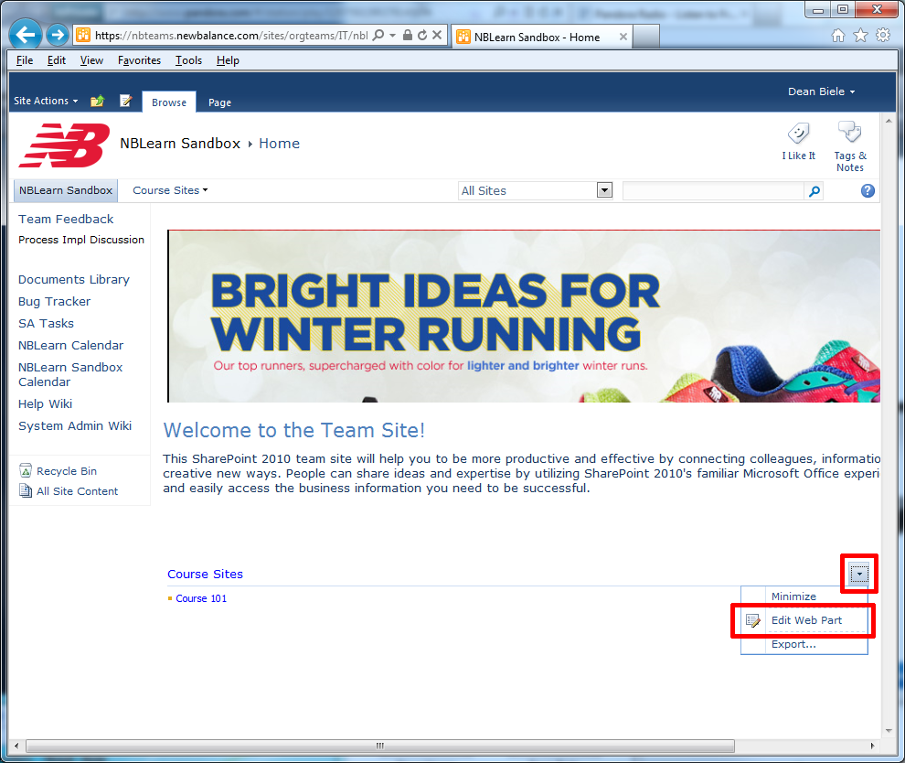

* Add a new course to the list by clicking the “New Link” button.

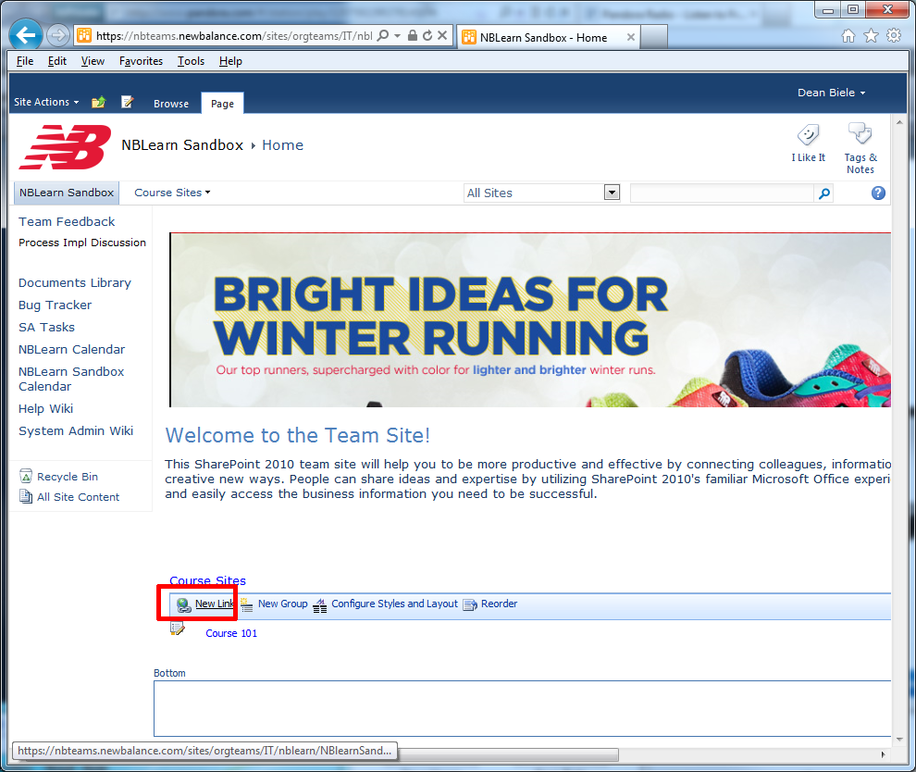

* Add the course title by entering text into the Title filed. Add a Link URL to link to the course site. Click “OK” to commit the information.

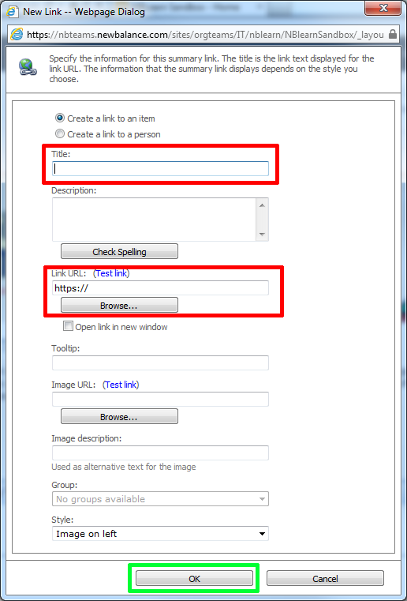

* Click the NBLearn Sandbox link to return to the main page.

